ASSIGNMENT 1 FRONT SHEET

Qualification | BTEC Level 5 HND Diploma in Computing
Unit number and title | Unit 1: Programming
Submission date |  | Date Received 1st submission
Re-submission Date |  | Date Received 2nd submission
Student Name | Ngo Tieu My | Student ID | GCD19832
Class | GCD0805 | Assessor name | Hoang Nhu Vinh
Student declaration
I certify that the assignment submission is entirely my own work and I fully understand the consequences of plagiarism. I understand that making a false declaration is a form of malpractice.
 |  | Student’s signature | My
Grading grid
P1 | M1 | D1

❒ Summative Feedback: ❒ Resubmission Feedback:

Grade: | Assessor Signature: | Date:
Lecturer Signature:

STUDENT NAME : Ngo Tieu My
STUDENT ID : GCD19832
CLASS : GCD0805

PROGRAMMING ASSIGNMENT 1
PROBLEM SOLVING WITH ALGORITHMS
Contents
ACKNOWLEDGEMENT 7
INTRODUCTION 8
1. Scenario 8
2. Report objective 8
CHAPTER 1: ALGORITHM AND OUTLINE THE PROCESS IN BUILDING AN APPLICATION 9
1. Definition of algorithm 9
2. Characteristics of an algorithm 10
3. Steps to writing a program 10
3.1 Understand the problem 10
3.2 Design a solution 10
3.3 Draw a flow chart 10
3.4 Write pseudo-code 11
3.5 Write code 11
3.6 Test and debug 11
3.7 Test with real world users 12
3.8 Release program 12
3.9 Iterate the steps for the next version 12
CHAPTER 2: SOLVING A CHOSEN PROBLEM 13
1. Understand the problem 13
2. Design a solution 13
3. Draw a flow chart 14
4. Write pseudo-code 15
5. Write code 15
6. Test and debug 16
6.1 Testing 16
6.2 Debugging 16
7. Release program 16
8. Iterate the steps for the next version 16
CHAPTER 3: EXAMINE AND EVALUATE THE WRITTEN ALGORITHM AND THE CODE 17
1. Examine how an algorithm is executed in an appropriate language 17
2. Evaluate the relationship between the written algorithm and the code variant 17
REFERENCES 18
INDEX OF COMMENTS 19

TABLE OF FIGURES
Figure 1: Flow chart of an example algorithm 9
Figure 2: Flowchart symbols 11
Figure 3: Flow chart of a program 14
Figure 4: Source code of a program 15
Figure 5: Output of a program 16

ACKNOWLEDGEMENT
First of all, I would like to thank the responsible individuals at Greenwich University who are providing the student with this coursework. I wish to thank all the authors and scholars whose research sources I have used in my report. I also wish to express my gratitude to our lecturer, Hoang Nhu Vinh, for his excellent and qualified lectures and guidance. Last but not least, I would like to thank supportive teachers and staff from our Department, GCD0805, for providing such a good learning atmosphere.

INTRODUCTION

Scenario

I have applied with a software development company for a position as a trainee, and have been invited for an interview. I was asked to show the problem solving skills and basic programming competencies. To do this, I will write a study on how to use algorithms to solve simple business problems.

Report objective
This target of this report is providing a definition of algorithm, how algorithms are used to solve simple business problems and steps needed to be followed to procedure a working program solution. Following that, stating my simple business problems to be solved and design the suitable solutions.

CHAPTER 1: ALGORITHM AND OUTLINE THE PROCESS IN BUILDING AN APPLICATION

Definition of algorithm
According to (Christensson, 2013), an algorithm is a set of instructions for performing a given task. This can be a simple process, such as multiplying two numbers or playing a compressed video file, or a complex operation. Search engines use proprietary algorithms to display specific queries with the most important results from their search index.
Algorithms are also generated as functions in computer programming. These functions serve as small programs which a larger program may reference. For example, an application to display images may include a library of functions that each uses a custom algorithm to render various formats of image files. An image editing program may include algorithms designed for image data processing. Examples of image processing algorithms include cropping, resizing, sharpening, blurring, reduction of red eyes and improvement of colors.
For example, there is a task: count sum of the even numbers from 1 to 20. This task can be solved based on the following flowchart:
Input: All numbers in range 1-20
Output: Sum of all even numbers in range 1-20
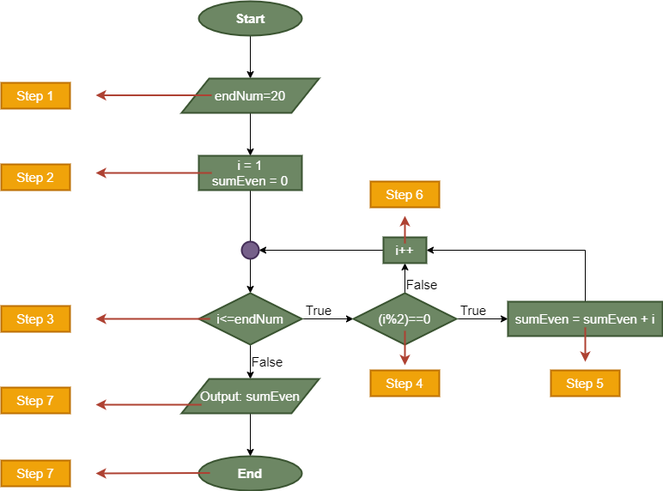
Figure 1: Flow chart of an example algorithm

Characteristics of an algorithm
According to (OWLGEN, n.d.), there are 5 main characteristics of an algorithm:
- Fineness: An algorithm must finish an infinite number of steps, and each step must be completed in a finite period of time.
E.g.: In figure 1, an example algorithm was described finitely 7 steps.
- Definiteness: Each algorithm step should be defined clearly and accurately, and no uncertainty should be present.
E.g.: In figure 1, each step did one definite function.
- Input: An algorithm must have zero or more but the number of inputs must be finite.
E.g.: Input of an example algorithm in figure 1: endNum = 20.
- Output: An algorithm must have at-least one desirable outcome, i.e., output.
E.g.: Output of an example algorithm in figure 1 is sum of even numbers from 1 – 20: sumEven.
- Effectiveness: The algorithm is expected to be effective. Effective means that each step should be referred to as the principle and finite-time execution should occur.

Steps to writing a program

Understand the problem
This is an important step. We cannot solve a problem unless we understand a given problem clearly. So that why the first step in building a program is analyzing a problem. Furthermore, a program source date, logical, practical procedures are needed to solve a problem. To understand a problem easily, we should break down problem into its components.

Design a solution
This is usually a hardest step. In this step, we will answer a question: How is program going to be done? We should design a plan with a logical step-by-step for solving a problem (design an algorithm). When designing an algorithm, consider whether the problem can be solved in more than one way. Following that, exploring each way and you can find the best way to solve that problem.

Draw a flow chart
A flowchart is a diagram representing a set of directions. Flowcharts usually use standard symbols to represent the various instruction types. These symbols are used to create the flowchart and display the solution to the issue step-by - step. The flowcharts can be used for program planning (BBC, n.d.).
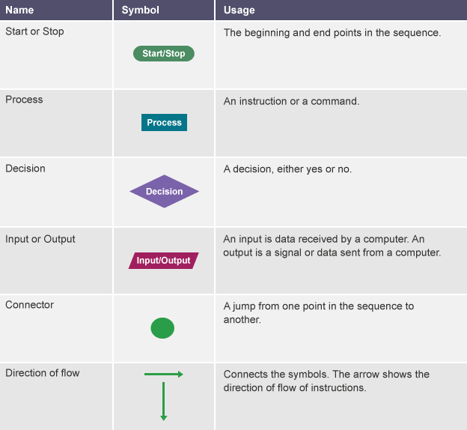
Figure 2: Flowchart symbols

Write pseudo-code
After you've figured out basic steps, writing a pseudo-code that can be converted into a code will help you define the structure of the code and make coding a significantly easier. Write the pseudo-code line to line. You can do this on paper or as a comment in the editor of your code. Don't get caught up with your syntax. Focus on the logic and on the steps (Chan, 2017).

Write code
When your pseudo-code is ready, translate each line into a real code in the language you’re working on. If you wrote it on paper, type it as a comment in your code editor. Replicate each line in your pseudo-code. Then you call the function and provide it a sample set of data you used earlier. You use them to see if the results you want are returned by your application. You may also write tests to verify that the real output is equal to the predicted output. You should use the logic that was built in the algorithm to write the program (Chan, 2017).

Test and debug
Some experts insist that the first time a well-designed program can be composed correctly. We say, in fact, that there are mathematical ways of proving a program is right. The world's imperfections are still with us, though, and most programmers get used to the fact that their newly developed programs will have a few mistakes. At first, this is a little disappointing because programmers tend to be accurate, careful, detail-oriented individuals who take pride in their work. Still, there are many opportunities for mistakes to be made in programs, and you will probably find several of them just like those who have gone before you (Anon., n.d.).
Debugging is an important part of deciding whether it is misbehaving an operating system, program, or software. Particularly if engineers follow the same coding style it is more than possible that there will always be glitches in a new software system. In certain situations, the development phase of a new software program can take more time to write the program than it takes. Generally, the bugs found and fixed first in software components that get the most use are (TechTarget, n.d.).

Test with real world users
Using real-world testing, you can examine the effect of the program. It has clear advantages over virtual shelf tests. Sometimes, you can find the mistakes of your code from the real-world users.

Release program
After ensuring that the risk of code failure in production is reduced as much as possible and making a detailed release plan, you can release your program. To ensure users can make good use of your application, you need to send them an instruction document.

Iterate the steps for the next version
You may receive feedback from users during the release process. From these feedbacks, you need to draw up a detailed plan to improve product quality and release an improved version in the future.

CHAPTER 2: SOLVING A CHOSEN PROBLEM

Understand the problem
Problem: The user will enter an array of integers. The program will arrange the numbers in the array in ascending order.

Draw a flow chart
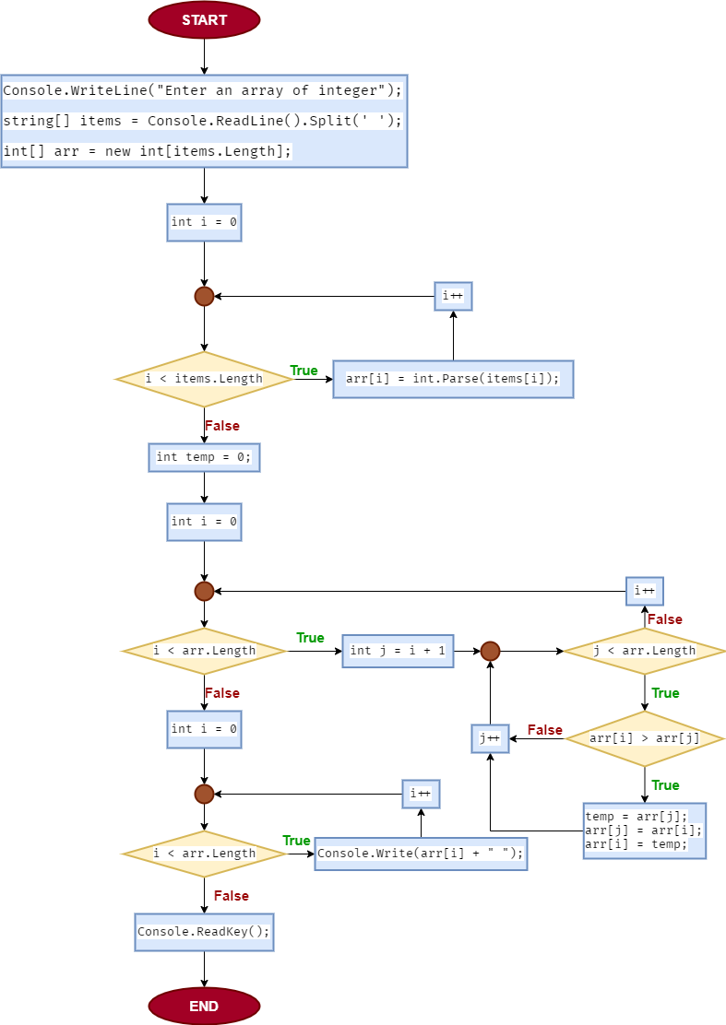
Figure 3: Flow chart of a program

Write pseudo-code
Step 1: Get an array of integers from user.
Step 2: Create a loop through all elements in array to sort.
Step 3: Compare the adjacent elements.
Step 4: Swap them.
Step 5: Print result after sorted.

Write code
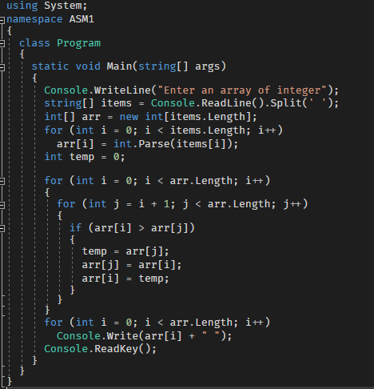
Figure 4: Source code of a program

Test and debug

Testing
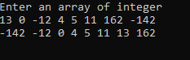
Figure 5: Output of a program
Test case ID | Test Data | Expected result | Actual result | Status: Pass/Fail
TC01 | 15 0 25 -99 1223 | -99 0 15 25 1223 | -99 0 15 25 1223 | Passed
TC02 | 734 -55 0 23 11 | -55 0 11 23 734 | -55 0 11 23 734 | Passed
TC03 | 1556 -1555 32 98 | -1555 32 98 1556 | -1555 32 98 1556 | Passed
TC04 | 123 329 -888 6 0 | -888 0 6 123 329 | -888 0 6 123 329 | Passed
TC05 | -22 -34 -65 -123 0 | -123 -65 -34 -22 0 | -123 -65 -34 -22 0 | Passed
Table 1: Testing case table

Debugging
Show cách dùng debug

CHAPTER 3: EXAMINE AND EVALUATE THE WRITTEN ALGORITHM AND THE CODE

Examine how an algorithm is executed in an appropriate language

Evaluate the relationship between the written algorithm and the code variant

REFERENCES

Anon., n.d. Computer Programming. [Online] Available at: https://homepage.cs.uri.edu/faculty/wolfe/book/Readings/Reading13.htm [Accessed 4 June 2020].
BBC, n.d. Designing an algorithm. [Online] Available at: https://www.bbc.co.uk/bitesize/guides/z3bq7ty/revision/1 [Accessed 3 June 2020].
Chan, V., 2017. 10 Steps to Solving a Programming Problem. [Online] Available at: https://codeburst.io/10-steps-to-solving-a-programming-problem-8a32d1e96d74 [Accessed 3 June 2020].
Christensson, P., 2013. Algorithm Definition. [Online] Available at: https://techterms.com/definition/algorithm [Accessed 3 June 2020].
OWLGEN, n.d. What is an Algorithm? Explain characteristics of an algorithm with the help of an example. [Online] Available at: https://www.owlgen.in/what-is-an-algorithm-explain-characteristics-of-an-algorithm-with-the-help-of-an-example/ [Accessed 3 June 2020].
TechTarget, n.d. Debugging. [Online] Available at: https://searchsoftwarequality.techtarget.com/definition/debugging [Accessed 4 June 2020].

INDEX OF COMMENTS

